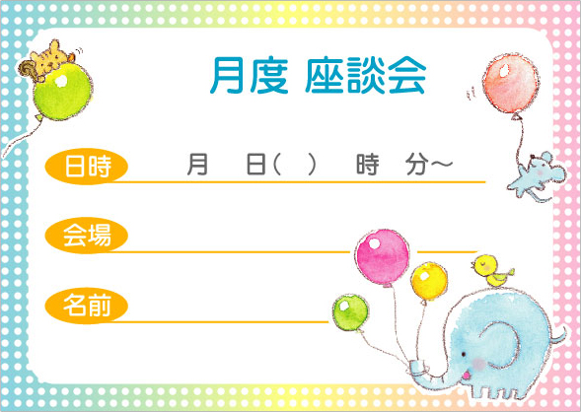
00 00 ○ 00 00
○○○
○○○
00

00 00 ○ 00 00
○○○
○○○
00
00 00 ○ 00 00
○○○
○○○
00

00 00 ○ 00 00
○○○
○○○
00

