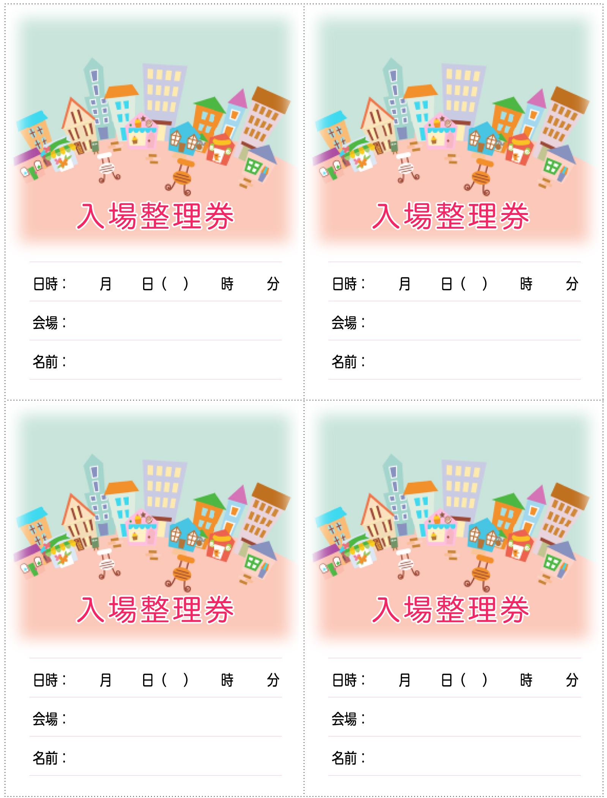
00 00 ○ 00 00
○○○
○○○
00 00 ○ 00 00
○○○
○○○
00 00 ○ 00 00
○○○
○○○
00 00 ○ 00 00
○○○
○○○

