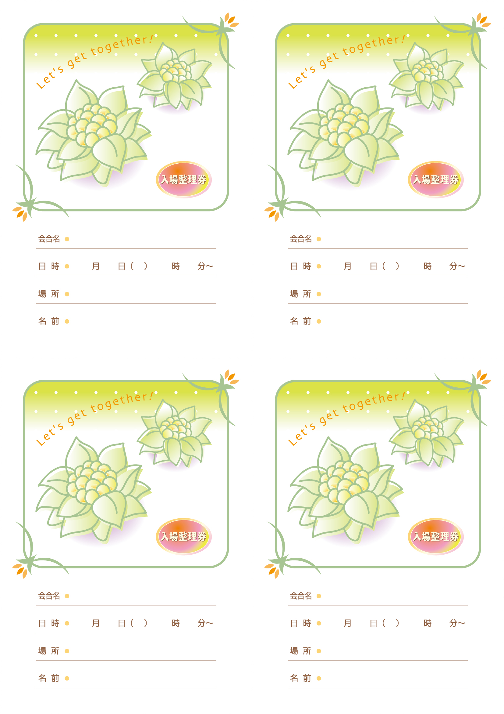
00 00 ○ 00 00
00 00 ○ 00 00
00 00 ○ 00 00
00 00 ○ 00 00

