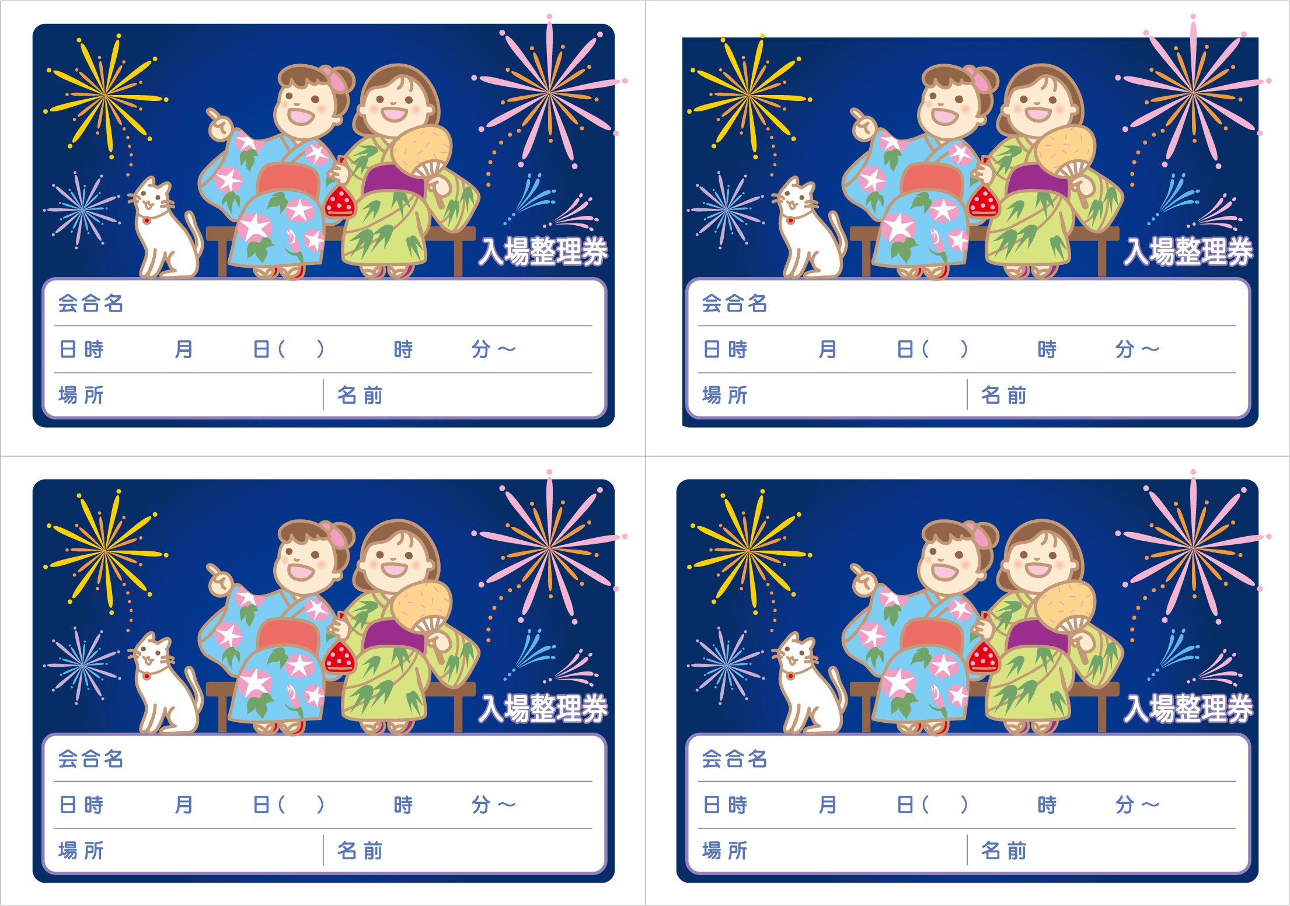
00 00 ○ 00 00

00 00 ○ 00 00

00 00 ○ 00 00

00 00 ○ 00 00

