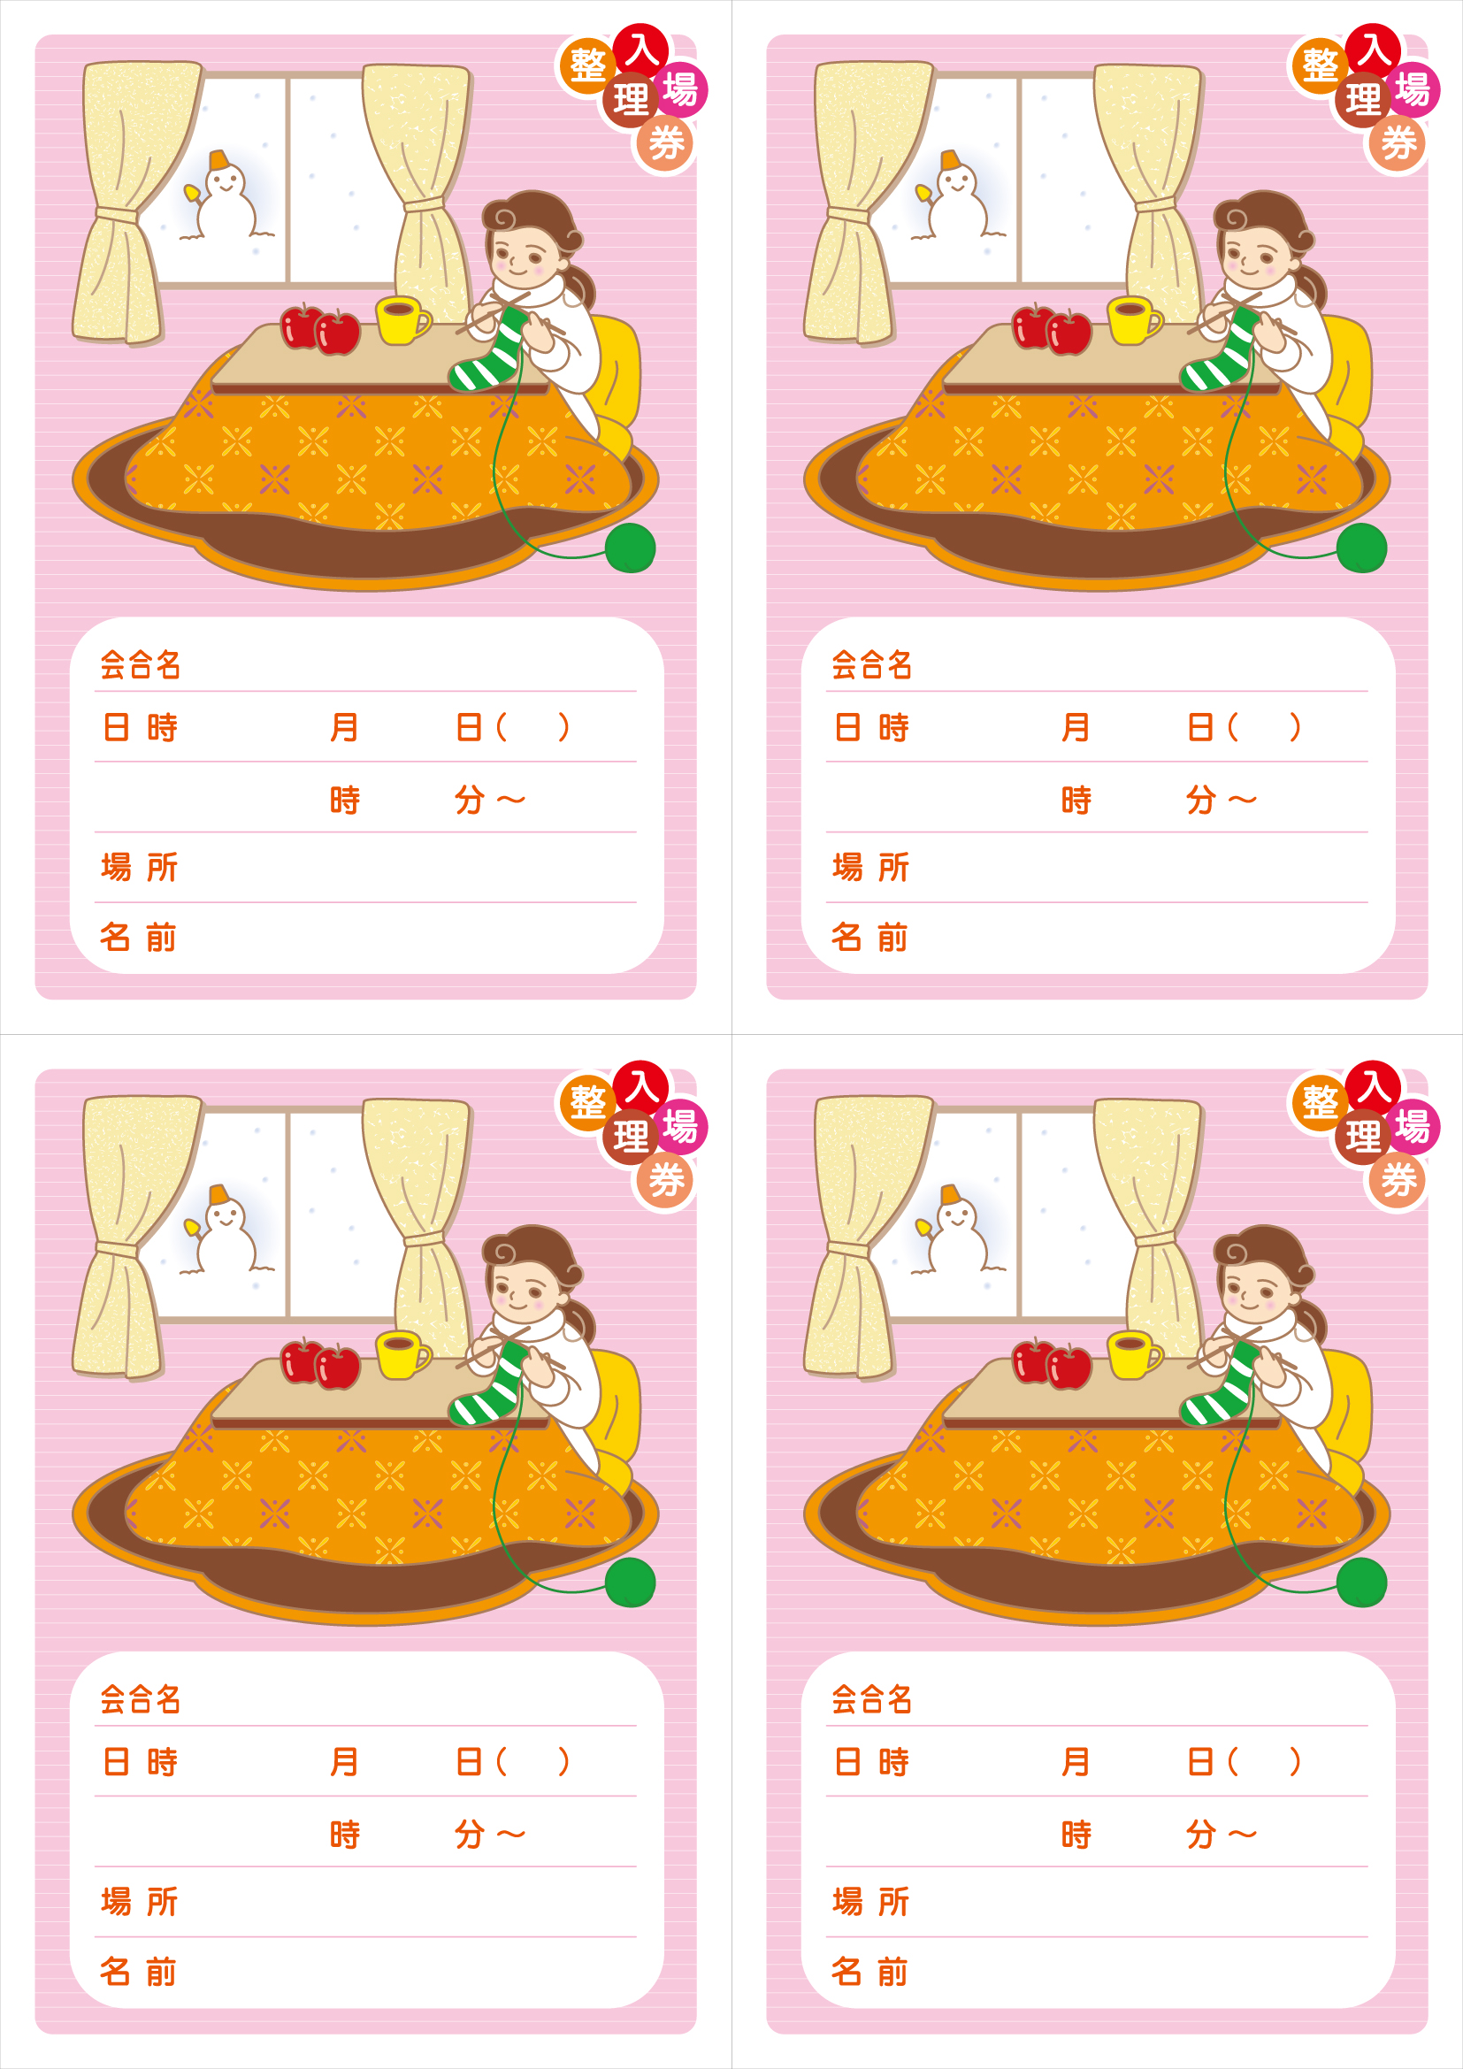

00 00 ○
00 00

00 00 ○
00 00
00 00 ○
00 00

00 00 ○
00 00

