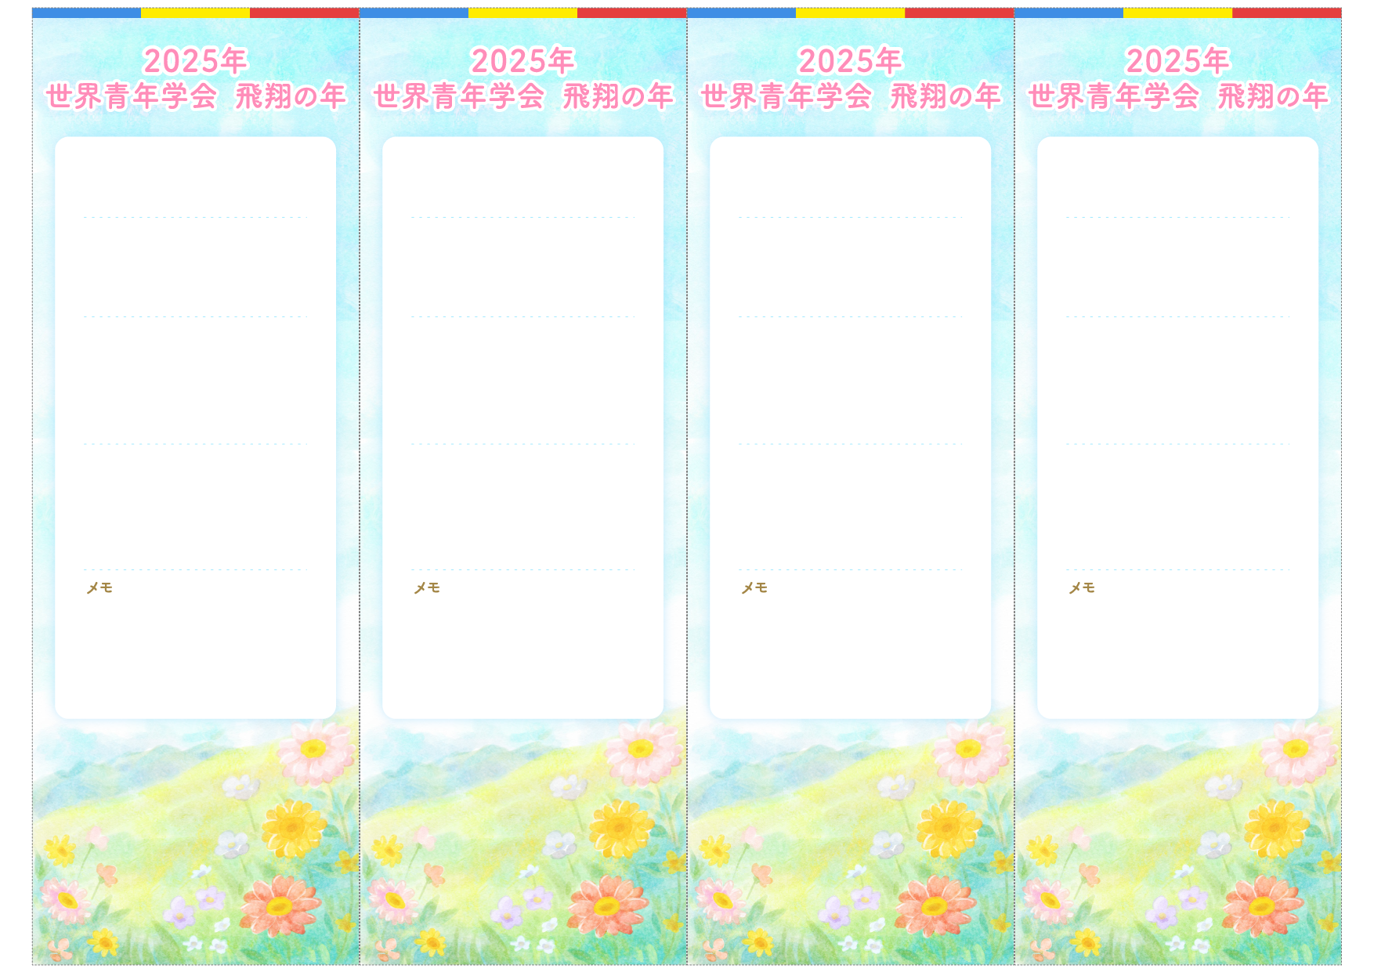

＊＊＊＊＊＊＊

８月＊＊日（＊）＊＊：＊＊〜

８月＊＊日（＊）＊＊：＊＊〜

＊＊＊＊＊＊＊

＊＊＊＊＊＊＊

＊＊＊＊座談会

＊＊　＊＊　様

＊＊　＊＊　様

＊＊＊＊座談会

＊＊＊＊＊＊＊

＊＊＊＊＊＊＊

８月＊＊日（＊）＊＊：＊＊〜

月＊＊日（＊）＊＊：＊＊〜

８月＊＊日（＊）＊＊：＊＊〜

＊＊＊＊＊＊＊

＊＊　＊＊　様

＊＊　＊＊　様

＊＊＊＊座談会

＊＊＊＊座談会

＊＊＊＊＊＊＊

＊＊＊＊＊＊＊

８月＊＊日（＊）＊＊：＊＊〜

８月＊＊日（＊）＊＊：＊＊〜

＊＊＊＊＊＊＊

＊＊＊＊＊＊＊

８月＊＊日（＊）＊＊：＊＊〜

８月＊＊日（＊）＊＊：＊＊〜

＊＊＊＊＊＊＊

＊＊＊＊＊＊＊