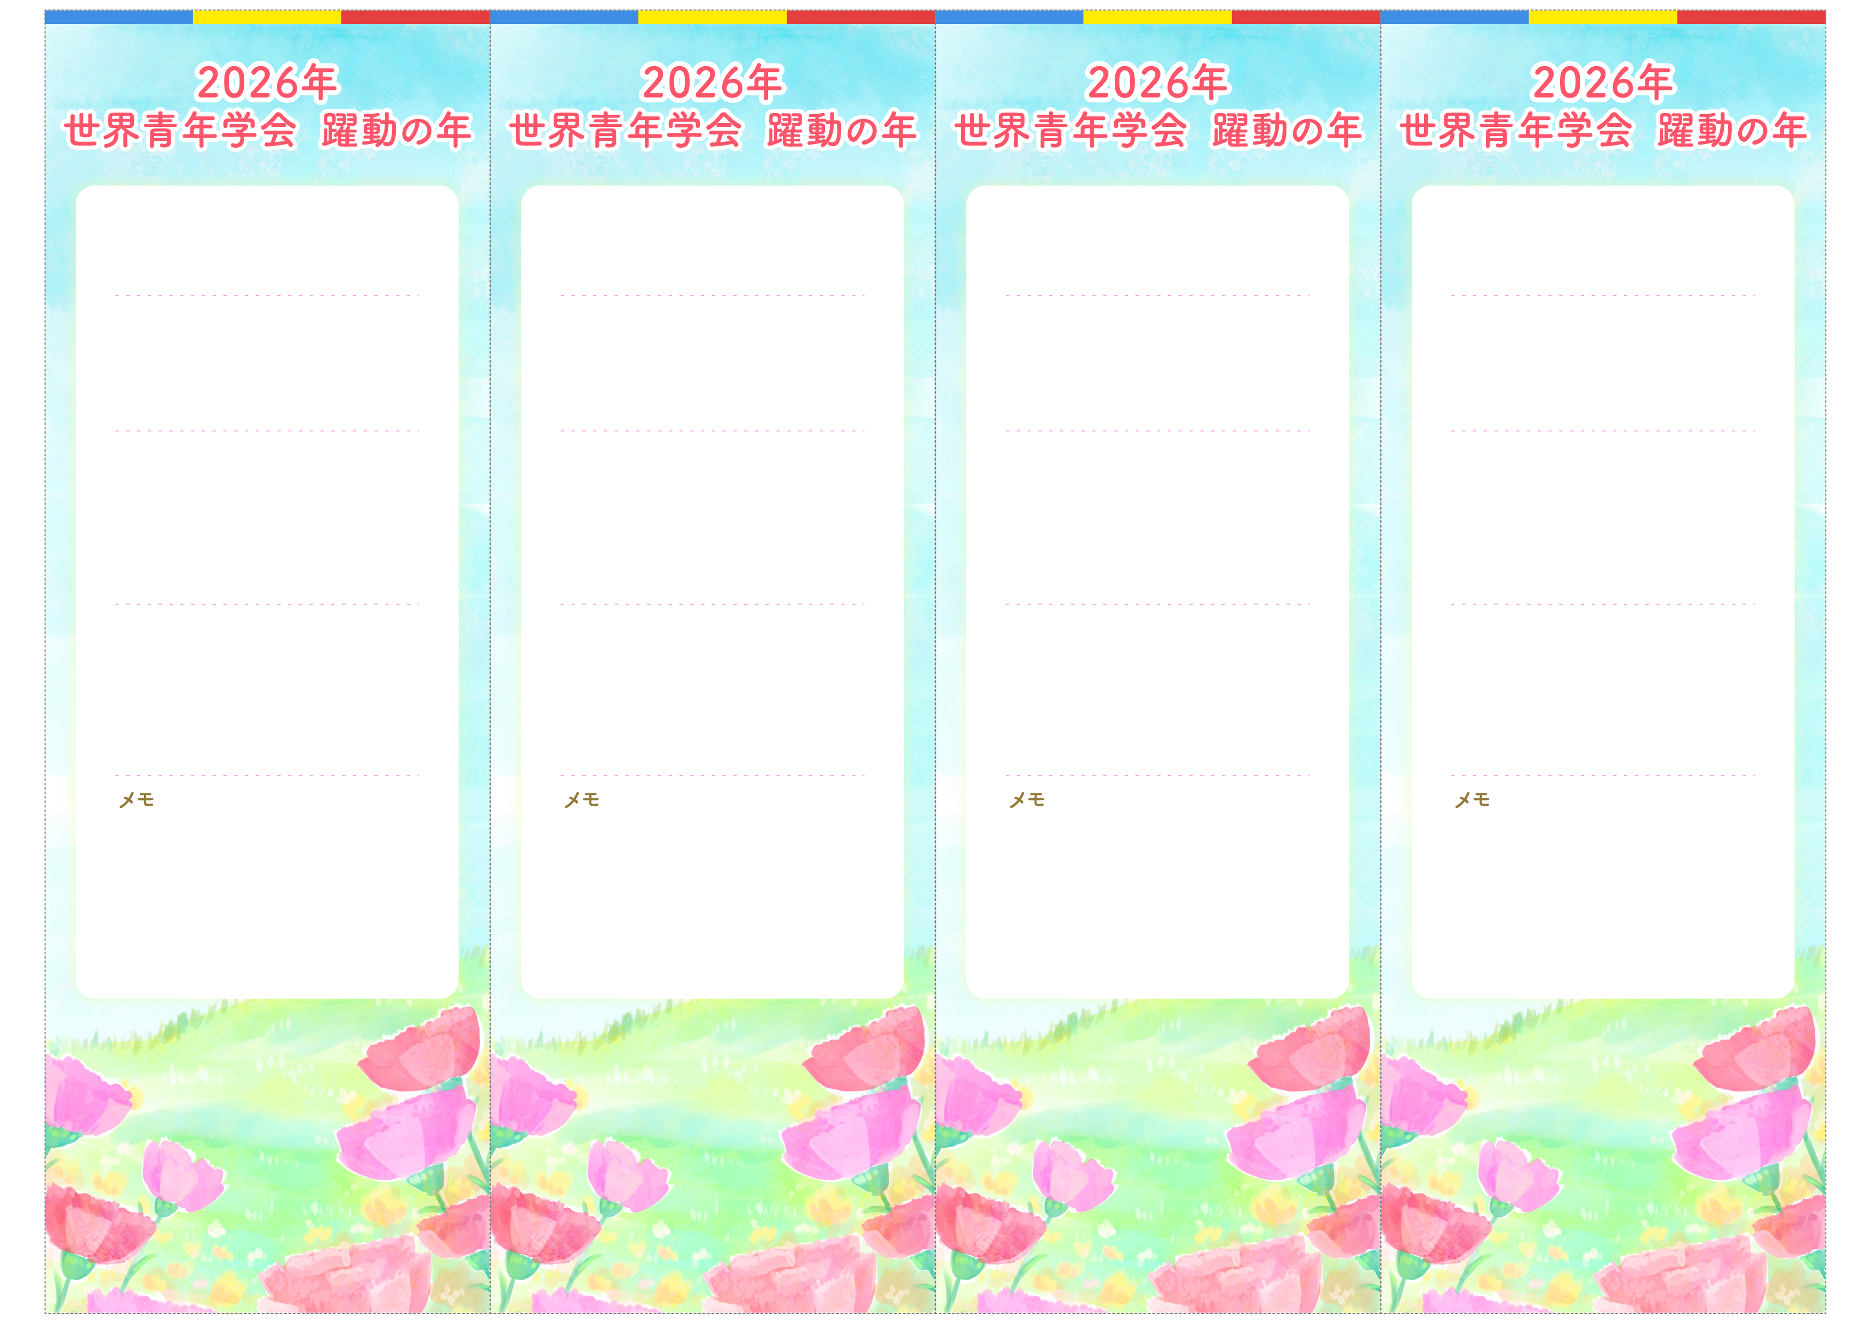
＊＊ ＊＊ 様
＊＊ ＊＊ 様
＊＊＊＊＊＊＊
＊＊＊＊＊＊＊
＊＊＊＊＊＊＊
＊＊＊＊＊＊＊

５月＊＊日（＊）＊＊：＊＊〜
５月＊＊日（＊）＊＊：＊＊〜
＊＊＊＊＊＊＊

５月＊＊日（＊）＊＊：＊＊〜
＊＊＊＊＊＊＊

＊＊＊＊＊＊＊
＊＊＊＊＊＊＊
＊＊＊＊＊＊＊
５月＊＊日（＊）＊＊：＊＊〜
５月＊＊日（＊）＊＊：＊＊〜
５月＊＊日（＊）＊＊：＊＊〜
＊＊ ＊＊ 様
＊＊ ＊＊ 様
＊＊＊＊座談会
＊＊＊＊座談会
＊＊＊＊座談会
＊＊＊＊座談会
＊＊＊＊＊＊＊
＊＊＊＊＊＊＊

５月＊＊日（＊）＊＊：＊＊〜
月＊＊日（＊）＊＊：＊＊〜
５月＊＊日（＊）＊＊：＊＊〜
＊＊＊＊＊＊＊

